

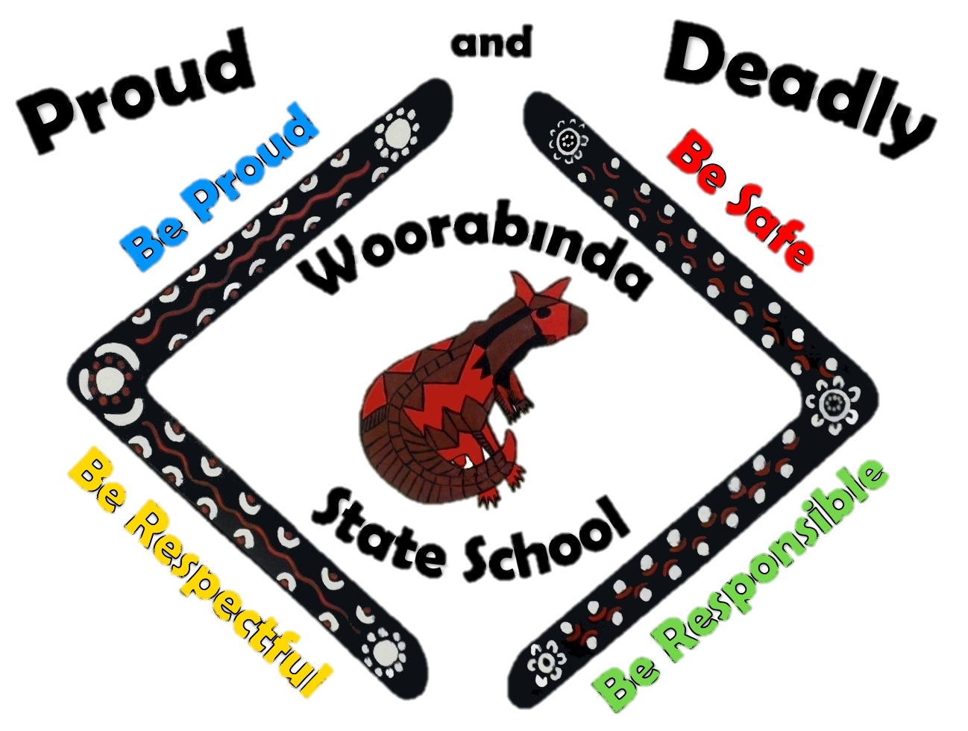
Woorabinda State School
Principal: Ms Tracey Egan
Email: the.principal@woorabinss.eq.edu.au

Address: 1 Carbine Street, Woorabinda Qld 4713
Phone: (07) 49 13 2222
Email admin@woorabinss.eq.edu.au

It is the start of a new school year and we know that a lot of things change over the Christmas break including your contact details.

To ensure your details are correct please take this form back to your classroom teacher or the front office staff at the beginning of the school year.

Please note it is a condition of enrolment that emergency contact details for your child remain current at all times.

Thank you for your cooperation.
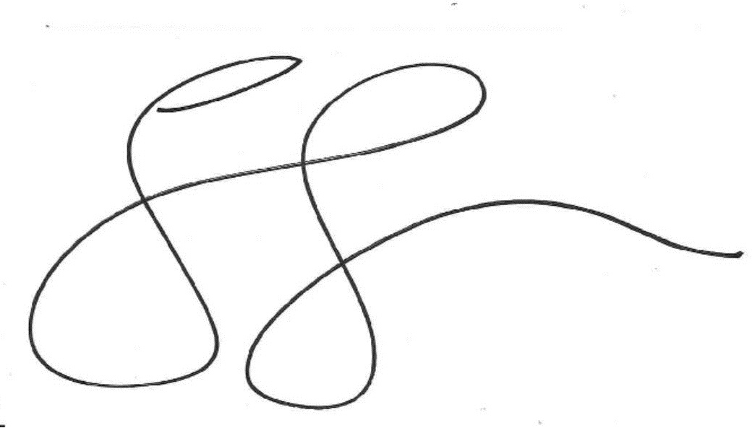
Tracey Egan
Principal
Name of Children who attend Woorabinda State School
(that you care for)
Address
Name of Parent/Carer
Relationship (Mother/Aunty)
Phone Number/s

Emergency contacts other than the Parent/Carer

Medicare Number

